**Progress Report No. 2**

Web Systems and Technologies

( Final Project )

|  |  |  |
| --- | --- | --- |
| **Project Title:** | Course Website | |
| **Date of Submission:** | May 3, 2018 | |
| **Class Code & Schedule:** | 9331A 3:00 – 4:00 pm TF | |
| **Project Manager** | Ryan Christian De Guzman (@rycdguzman) |  |
| **Members:** | Franchesca Derije (@chescaDerije) |  |
| Ivy Mae Palma (@aybimey) |  |
| Ceasar Jim Romero (@#3heycaesarjim) |  |
| Daren Sison (@DarenSison) |  |

**Task Assigned**:

Documentation: **Ryan, Ivy, Frnachesca**

Front end: **Caesar, Ryan**

Back End: **Caesar, Daren, Ryan**

Lectures / Content: **Everyone**

Week 2:

|  |  |
| --- | --- |
| **Accomplished Task** | **To be Accomplish** |
| 1. The contents must be integrated to the webpages. 2. Improved the Course website design making it interactive and add some multimedia. 3. Some of the functions are already integrated to the Course Website. | 1. Finalize the design and features of the course website 2. Finalize the functionalities that are integrated in the Course Website 3. Finalize the notes that will be included in the Course Website |

Technologies to be used:

Scripting Languages:

* PHP
* JavaScript
* HTML/CSS

Framework:

* + - Bootstrap

### Project Related Issues

Below are the lists of some of the possible issues or problems that the team might encounter while developing the project:

* How will the online quizzer be accessed by the users?
* What are the different topics to be put on the website?
* How many users can the website and the online quizzer accommodate?
* Will the online quizzer produce an accurate result in checking the answers?
* Will the online quizzer be responsive that even a mobile phone can access it?
* Will the website resists unauthorized users?

### Improvements

Below are the lists of some of the improvements that the team developed:

* Changed the background image in some section.
* Added some the functionalities of the course website.
* Organization of the course website was improved.
* Added syllabus for the finals topics.
* Added some educational videos which relate to the finals topics.
* Questions that will be included in the Course Website are accomplished.

**Output Screenshots**:



***Figure 1 Homepage of the Website***

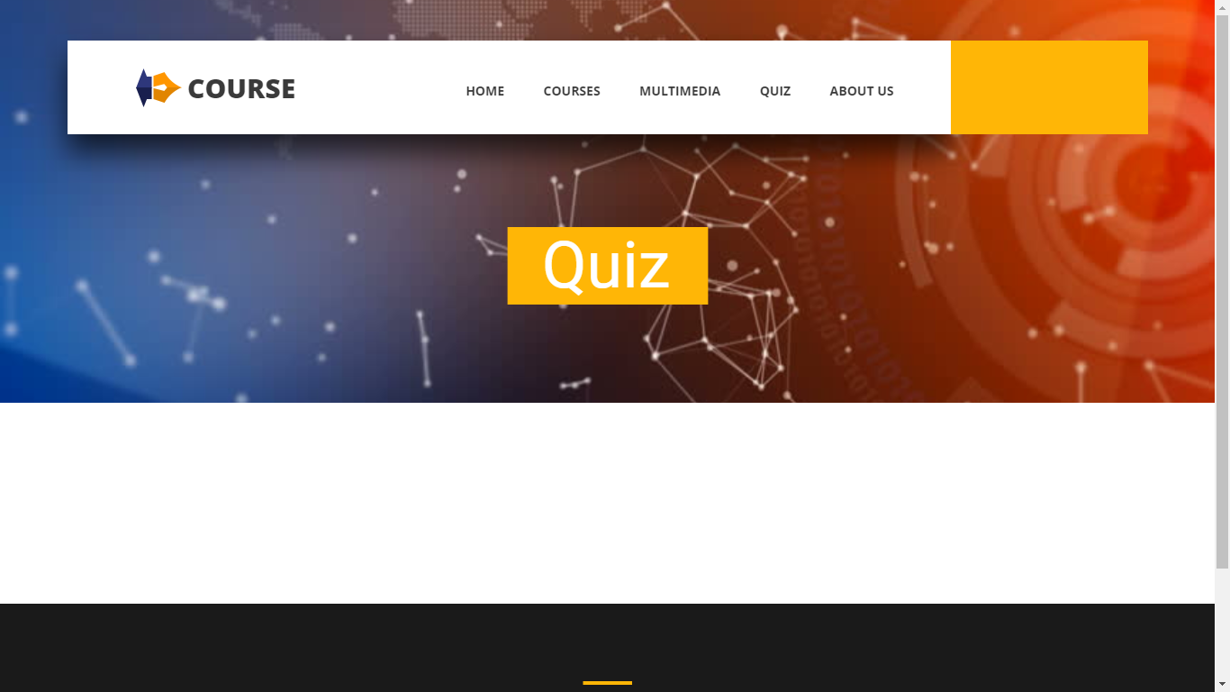

***Figure 2 Quiz page of the Website*** 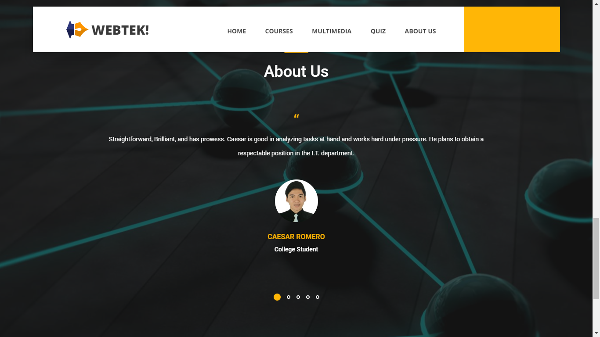

***Figure 3 About Us page of the Website***



***Figure 4 Introduction of the Website***

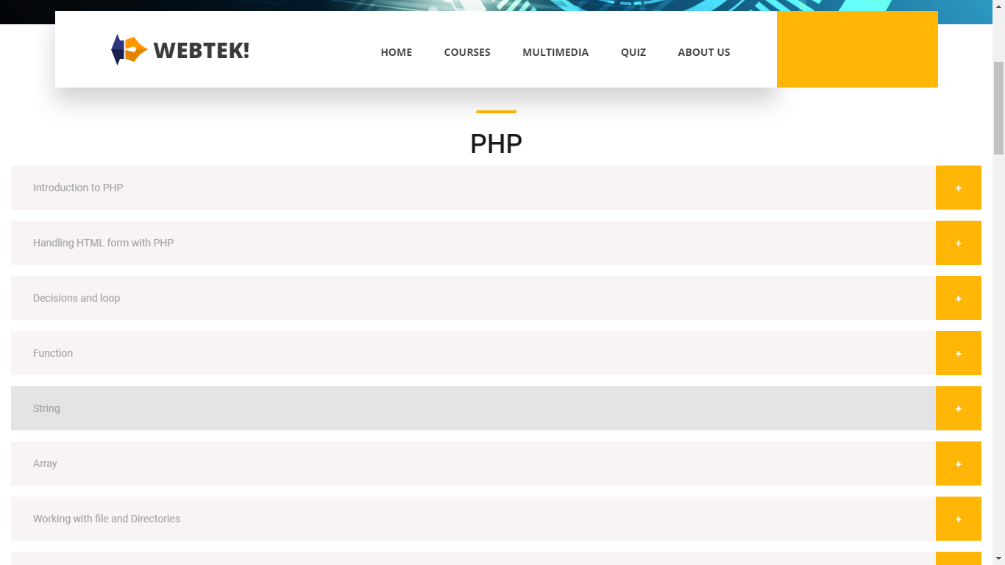

***Figure 5 Course page of the Website***

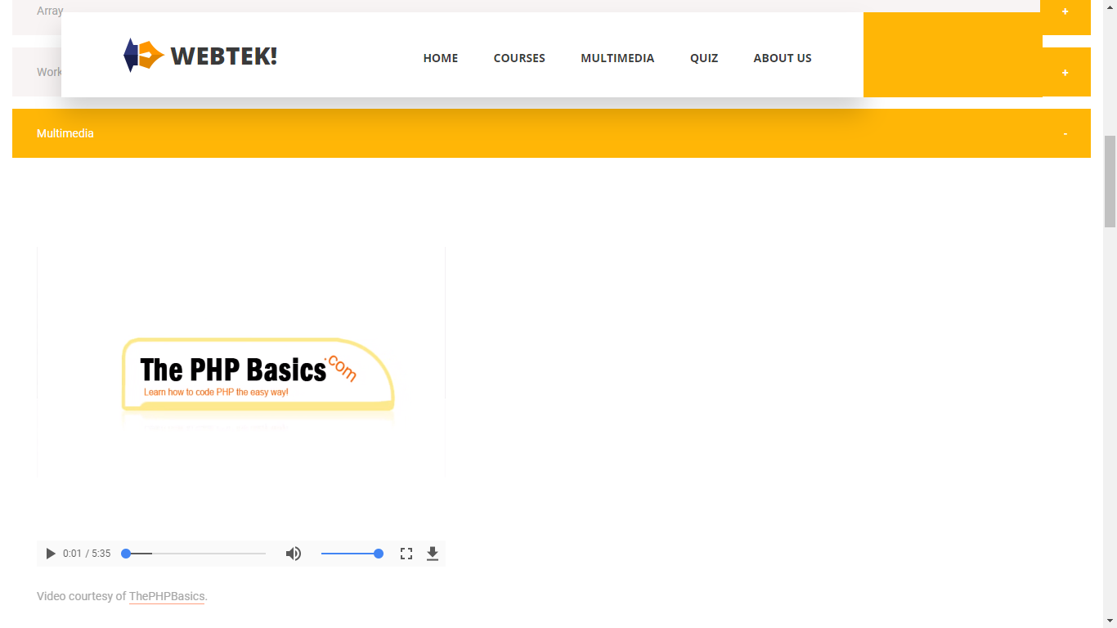

***Figure 6 Multimedia page of the Website***

**Project Meeting**

Meet up – May 2, 2018

Members involved: Ryan, Caesar